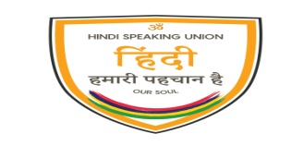

हिंदी स्पीकिंग यूनियन

**HINDI SPEAKING UNION**

Under the aegis of

Ministry of Arts and Cultural Heritage

Hindi Inspirational Song Festival 2021

Goodlands Arya Samaj Mandir,

Friday 29 January 2021 - 5.30 p.m. to 7.30 p.m.

भाव गीत महोत्सव 2021

**PARTICIPATION FORM**

Name of Singer………………………………………………………………………..........................................................

Name of Lead Singer/Group………………………………………………………………………...................................

Address of Singer/Group…………………………………………………………………………......................................

Title of Film: ………………………………………………………………………………………..........................................

First Line of the Lyric (song)………………………………………………………………………..................................

Musical Accompaniment Details ………………………………………………………………….................................

Karaoke or Live (specify)…………………………………………………………………………......................................

Solo or Duet (specify)……………………………………………………………………………….....................................

Dramatization of the item is encouraged, but all costumes and make-up will be at the expense of the singer /group.

**Incentive**

A travelling allowance, varying from Rs 500 to Rs1000 depending on regions will be given only to those singers or groups who will be accompaniedby musicians.

All singers/groups who will perform on live music are requested to bring their own musical instruments.

N.B Participation Form could be accessed from our Website hindispeakingunionmauritius.org and filled in electronically, or it could be sent by way of fax, email or letter.

For any further information, please contact on 208-7193 during office hours.

Deadline for submission of Participation Form is 15 January 2021.

* Child and young singers are also encouraged to participate.

11th Floor, Hennessy Court, Pope Hennessy St, Port Louis – Tel: 2087189/93-Fax 2087894